**CURRICULUM VITAE**

Name: **Xingchao Bian**

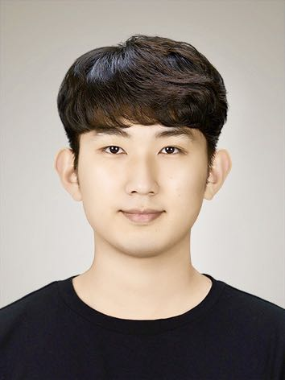

M/F: M

Date of Birth: 09-23-1995

Nationality: China

Department of Software

College of Computing

Sungkyunkwan University (Natural Science Campus), Korea

Corresponding Address: Shahezhen, Laizhoushi, Yantaishi, Shandong Province

Korea Mobile No.: 82-10-2376-6690

China Mobile No.: 18865584138

KakaoTalk ID: bxc8802

WeChat ID: bxc728063647

E-mail: [bxc8802@g.skku.edu](mailto:bxc8802@g.skku.edu) / [xingchao_110@hotmail.com](mailto:xingchao_110@hotmail.com)

**Education**

* Bachelor of Engineering (Feb. 2016 - Feb. 2020)
* Major: Computer Science and Engineering
* Inha University, Inchon, Korea
* Research Advisor: Prof. YOUNGTAE NOH
* GPA: 3.77/4.50
* Percent: 91.66/100.0
* MD-PhD of Engineering (Mar. 2020 - present)
* Major: Computer Science and Engineering (SKKU Suwon Campus)
* Combined major: Fintech (SKKU Seoul Campus)
* Sungkyunkwan University, Suwon, Korea
* Supervisor: Prof. HYUNGMIN CHO
* GPA: 4.08/4.50
* Paper:
  1. Detecting Anomalies in Time-Series Data using Unsupervised Learning and Analysis on Infrequent Signatures / Journal of IKEEE, 24(4), 1011-1016 / KCI Published
  2. Detecting Cache-based Side-Channel Attacks by Leveraging Mesh Interconnect Traffic Monitoring, Submission

**Research Interests**

Hardware Security (Processor Security)

Side-channel Attack Technology

Deep Learning

Financial Technology

**Experiences**

* Mentor of Inha Tutoring Program (Selection by grade)
* Discrete Mathematics (2018.2-2018.6)
* Introduction of Computer Programming, Python (2018.9-2018.12)
* Introduction of Computer Programming, Python (2019.9-2019.12)
* Well - being Health Pharm Trade Company Internship (2018.6 2018.8)
* Location: Korea Inchon
* Position: trade assistant
* Work: Company related products research, market analysis, marketing image production, advertising, document translation
* Undergraduate Student Intern (2019.2-2019.8)
* Location: Korea Inchon
* Inha University, NSL Lab (Networked System Laboratory)
* Advisor: Prof. YOUNG TAE NOH
* Work: Deep learning in emotion recognition, portable and low-energy Position Tracker (for the old and the young missing issue)
* Graduate Student Full-time (2020.3-2022.3)
* Location: Korea Suwon
* Advisor: Prof. HYUNGMIN CHO
* SKKU, CPL Lab (Computing Platforms Laboratory)
* Work: Security vulnerability inspection technology in processor interconnection field – analysis system construction by monitoring the mesh interconnect
* Online Channel Product Sales Forecast AI Competition, 2023.07.01 ~ 2023.08.28
* Development of B2B Sales Opportunity Creation Forecast Model based on MQL Data, 2024.02.01 ~ 2024.02.26
* (주)EnF Advisor Intern (2023.8-2024.2)
  + Location: Korea Yeouido
  + Position: Data Analysis
  + Work: 노란우산공제회 Financial Estimation Research Service

**Skills**

* TOPIK (Test of Proficiency In Korean) 6/6 level, 2020
* TOEIC (Test of English for International Communication) 730/990, 2019

**Awards**

* International Scholarship (4 Years) in Inha University
* STEM Scholarship of Science and Engineering Department (MD-PhD) in SKKU
* HAICon2020 Industrial Control System Security Threat Detection AI competition 9/267
* Sungkyunkwan University Graduate School of Integrated Security Hackathon Individual Award, 2021